**Poetry Setup: How to create the virtual environment.**

Poetry update

Poetry show

Poetry install

Pip list

Case# initial

We need to install the Poetry first, after creating the poetry project by “pip install poetry”

**Case#1: Brian shared the poetry project to me.**

If project contains a poetry.lock or pyproject.toml file then can use poetry (package dependency manager) to install all packages required in project

Make sure that poetry is installed first and setup correctly

Open a Powershell (in Admin mode) and change directory to path that your project resides in

(along with the poetry.lock & pyproject.toml files)

To install a project (1st time), run "poetry install" command

This will start to install all required packages and it can also check that you have a suitable Python version installed

The "poetry install" command will create a virtual environment for your project and install all the required packages inside this virtual environment

Once this is done, you can open up VSC from the command prompt by typing "code ."

Your virtual environment shell should already be running, after the "poetry install" command has executed successfully

In VSC, ensure that the kernel is using your projects 'virtual environment’

Continue to run all your code in your project

When you are finished, close VSC and return to the Powershell window...type "exit"...this will close down your projects 'virtual environment'

Type "exit" again to close Powershell

When you want to work on your project again, open up Powershell, change directory to the path of your project (and poetry.lock & pyproject.toml files), type "poetry shell" to start your projects' virtual environment, then type "code ." to start VSC after your virtual environment shell starts

Repeat the above to shut everything down

When you want to add a new package to or update an existing package in your project...modify the pyproject.toml file first,

then go to your Powershell window and type "poetry update"...this will install new packages or update existing packages to whatever you have requested

**Case# New Project**

1. If you are creating a new project from scratch, use the "poetry new <name_of_project>" command
2. Create the virtual environment “ poetry shell” command

1. Install poetry.lock “poetry install” command

This poetry shows up in VSC



1. Add the python package for project requirement in pyproject.toml

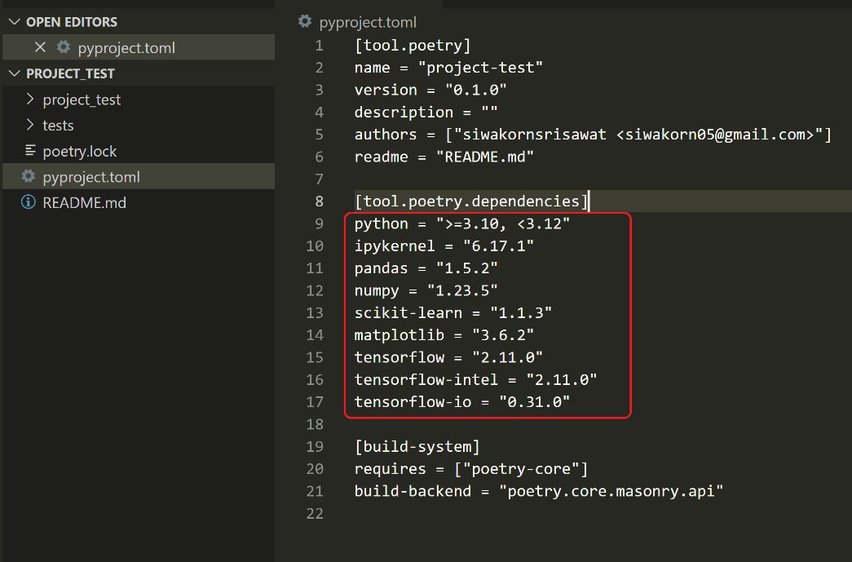

ipykernel = "6.25.2" (this is manually by poetry update)

1. In Powershell run “poetry update” command to install all packages as listed above.

1. In powershell run “poetry show" command to compare the installed packages Vs the list requirement
2. Open the project in the VSC.



1. VSC will popup

1. Select the project name and go to File and create the “New File” and select the Juperter Notebooks

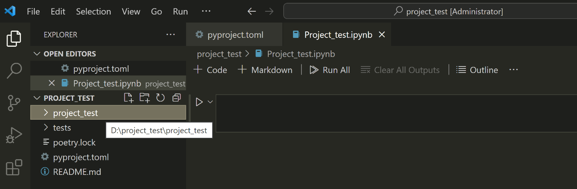

1. Create the code and select the Kurnel

1. Under the View menu select Command Palette... F1 (or press F1 key).

Type Python: Select Interpreter.

Choose which Python version to use by default [1].

